MARlON
TECH liCAL COLLEGE

MEDICAL CLINICAL LABORATORY TECHNICIAN

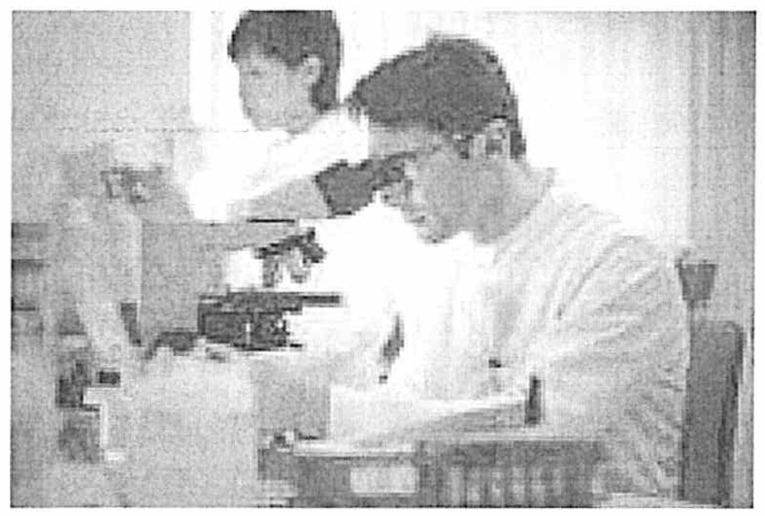

The following items are required for your application to be considered complete:

- Copy of a valid FL driver's license

- Copy of car insurance and vehicle registration

- Copy of your signed Social Security card (name must match FL driver's license)

- Copy of high school diploma or GED diploma

- Official, sealed high school transcripts

  - GED transcript is required if_ you received your GED
o If you have your GED, official sealed high school transcript is still required in addition to your GED transcript, even if it is incomplete.
- Official college transcripts (if applicable)

- Copy of college diploma (if applicable)

- Essay about why you are interested in the Medical Clinical Laboratory Technician program and what you know about the Medical Clinical Laboratory Technician profession
- Two (2) completed Professional Recommendation Letters o Applicant must sign the letter
  - References cannot be related to you; No family members, friends,
boyfriends, etc.
*Must know or be known to you for a year or more
- Read, sign and date technical standards
- Must attend ONE (1) Information Session: September 9, October 7 or November 11 for the July 2020 class.
All Information Sessions are on Monday nights at 6:00P.M.
- Complete the "My Career Shines" Assessment in Student Services

MEDICAL CLINICAL LABORATORY TECHNICIAN

The following will be required IF YOU ARE ACCEPTED into the Medical Clinical Laboratory Technician Program:

- PERT Test- This test is not required for admission. It must be completed within the First Six Weeks of class on your own time.
- To schedule a testing appointment, please contact Student Services at (352) 671- 4134.
  - If you have earned an AA Degree or higher, the PERT test may be omitted.
  - If you have taken the CPT, ACT or SAT within the last two years, you may also be exempt from the PERT test.
  - Due to the heavy workload, it is highly recommended to schedule your
PERT test prior to the beginning of classes.
  - If you have a GED from 2014 to present year, you are exempt from PERT.
  - If you received a standard Florida public high school diploma from 2008 to present you are exempt from PERT.

- Background check. We will provide paperwork upon acceptance.
Proof is due by Orientation, prior to the First Day of class.

- Immunizations- are required and we need proof by Orientation,prior to the First day of class:

  - Hepatitis B series, Tuberculosis (PPD), Measles Mumps Rubella (MMR), Varicella Zoster (Chicken Pox), Tetanus, Flu Shot evidence of immunizations or positive titers

    - If your TB Skin Test comes back positive, we will need a copy of your results from the chest X-Ray.

- Physical Examination- proof due by Orientation, prior to the first day of class.

MARION
TECH 'JI AL CO LLEGE

HEALTH SCIENCE

Use the following section to tell us in your own words, why you are interested in the Medical Clinical Laboratory Technician Program, as well as what you know about the Medical Clinical Laboratory Technician profession. (This essay MUST be handwritten. Cursive is preferred. However, this essay must be legible or it will not be valid) More than 10 full sentences.

Marion County Public Schools

1014 SW 7th Road, Ocala, Florida 34471 ·tel.352 .671.7219 ·fax 352.671.7221 · website:www.mariontc.edu

Equal Opportunity Schools

MA

TECHNICAL STANDARDS

HEALTH SCIENCE

Students who are accepted into the Health Science programs are required to be able to perform the following tasks:

- Walk the equivalent of five {5) miles a day.
- Grip, reach above shoulder level, bend at the knee, squat, stoop and crawl.
- Sit, stand for prolonged periods of time.
- Perform CPR/First Aid.
- Lift a minimum of 50 lbs.
- Manipulate small objects dexterously.
- Tolerate exposure to dust, fumes, chemicals, detergents, body fluids, and latex.
- Distinguish colors.
- See objects as small as 1mm.
- Hear subtle sounds, such as heart or lung sounds.
- Withstand varied environmental conditions such as heat, cold, and moisture .
- Cope with a high level of stress.
- Prioritize and make decisions fast under pressure.
- Cope with anger, fear, hostility and/or confrontation in a calm manner.
- Cope with death and dying.
- Concentrate.
- Be flexible and self directed.
- Problem solving.
- Demonstrate a high degree of patience and confidentiality.
- Communicate in writing and verbally.
By signing below, I acknowledge that I can perform all the tasks mentioned above. Applicant Signature:_________________

Print. Date _

Marion County Public Schools

1014 SW 7th Road, Ocala, Florida 34471
TELEPHONE: 352.671.7219 ·FAX: 352.671.7221· WEBSITE: www.mariontc.edu

Equal Opportunity Schools

1014 S.W. 71
h
Road

Ocala, FL 34471

Applicant:________________________
Please Print Signature*
(*By my signature, I authorize th e person below to answer the followin g question s to the best of their abi lity and submit this form to MCSRT) .

NOT TO BE COMPLETED BY FRIENDS OR FAMILY. ONLY PROFESSIONAL REFERENCES PLEASE. FORM MUST BE RETURNED DIRECTLY TO THE HEALTH SCIENCE OFFICE BY THE PERSON COMPLETING IT.

I) How do you know this individual? #of years

- Do you feel this individual would adapt and excel in a healthcare environment that is highly technological and highly patient? Yes No Not Sure Explain : _

- I have observed the following attributes in this individual (only check those that apply):
____ Cheerfulness ____ Self-Motivation ____Good Attendance Critical Thinking
Maturity _____Self-Confidence Team Player Problem Solving

Dependability ____ Initiative
Multi- Tasking Effective

Honesty ____ Punctual
Time Management
Communication

- What do you feel is this individual's greatest strength? Why? _

- What do you feel is this individual's greatest weakness? Wh:y.? _

- Give an example ofhow this individual demonstrated perseverance to achieve a goal or accomplish something important. _

- Additional comments :

1014 S.W. ?lh Road
Ocala, FL 34471

Applicant:_______________________
Please Print Signature*
(*By my signature , I authorize th e person below to answer the following questions to the best of their ability and submit thi s form to MCSRT) .

NOT TO BE COMPLETED BY FRIENDS OR FAMILY. ONLY PROFESSIONAL REFERENCES PLEASE. FORM MUST BE RETURNED DIRECTLY TO THE HEALTH SCIENCE OFFICE BY THE PERSON COMPLETING IT.

  - How do you know this individual? #of years

- Do you feel this individual would adapt and excel in a healthcare environment that is highly technological and highly patient? Yes No Not Sure Explain : _

- I have observed the following attributes in this individual (only check those that apply):
____Cheerfulness ____ Self-Motivation ____Good Attendance Critical Thinking
Maturity _____Self-Confidence ___ Team Player Problem Solving

Dependability _____Initiative
Multi- Tasking Effective

Honesty _____Punctual
Time Management
Communication

- What do you feel is this individual's greatest strength? Why ? .

- What do you feel is this individual's greatest weakness? Why:? _

5) Give an example ofhow this individual demonstrated perseverance to achieve a goal or accomplish something important.

6) Additional comments : ------------------------------------

